Netravati, a lifeline of Tulunaad
Karnataka government have been trying to divert west flowing rivers to east for many years. They got an opportunity when Netravati-Hemavathy Link was proposed by the National Water Development Agency (NWDA) as a part of peninsular component of the River linking project. In the meantime, Karnataka appointed a committee under the leadership of Dr. G. S. Paramasivaiya. He worked on a plan to divert waters from west-flowing river Netravati to 7 districts of Bayaluseeme.
The Paramasivaiya Report
Paramasivaiya had proposed two schemes for diversion of Netravati River Water in 2001.
Scheme 1: Scheme for diversion of Netravati river water to North and East. Mainly to supply water to Bayalu Seeme’ — the arid parts of Karnataka, where more than 2 crore people lives. Chikbalapura, Chitradurga, Bellary, Davangere, and Tumkur districts in which he expected 51.73 tmc water within a catchment area of 212 sq km by constructing the Garland Canal along 298 km of the Western Ghats.
Scheme 2: Diversion of Netravati river water to the east for drinking water and ground water recharge. In this scheme, total 90.73 tmc water was to be diverted from the Netravati river, 20.80 tmc through Garland Canal, 35.79 through constructing 27 reservoirs, and 14.14 by interconnecting canals.

image(source google earth): Actual stream of Netravati, originating from western ghats
In his report, he had suggested diversion of water from west flowing rivers to drought-hit areas through the principle of gravitational force. But according to experts, this scheme of diverting the Netravati River is totally unscientific and economically not viable. Already, the Western Ghats is being exploited by mining, encroachment, and deforestation.
Paramasivaiya proposed plan to construct open canal in mid rage of Western Ghat peak. Open canal will be constructed in such a way that it will divert all the Netravati streams before reaching coastal area. Catchment area also been identified at lowest peak area of Western Ghats, like Yelleneer and Bisle.
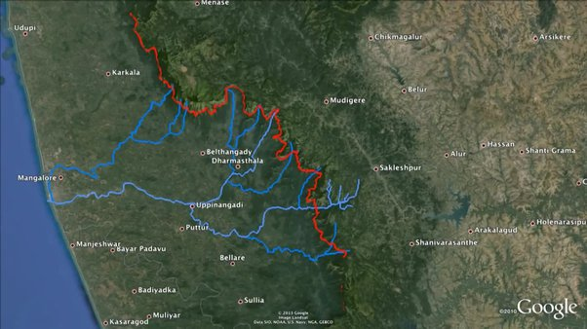
image(source google earth- ): Open canal construction plan marked in red and it covers all the Netravati tributaries and divert water back to east
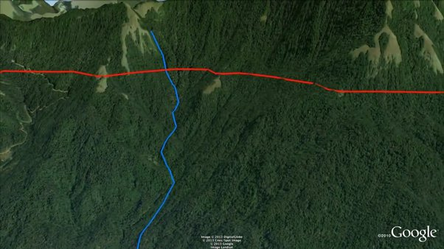
image(source Netravathi River Diversion Project youtube video by Abhaya Simha): Open canal marked in red will be constructed in Mid elevation of the peaks
As Netravati Diversion Project proposal getting delayed due to frequent change in Karnataka government. It is learnt that Paramasivaiya warned the government of staging a hunger protest in front of Vidhana Sowdha, if government fails to implement the project.
Mangalore protested
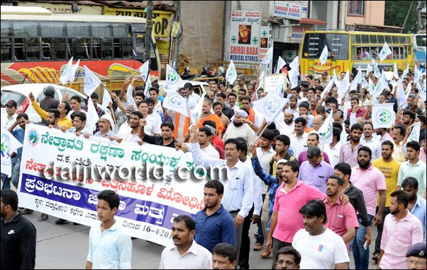
(image source: Daijiworld) Mangalore people protest against Netravati project
Due to widespread opposition by the people of Dakshina Kannada district to the Netravathi River Diversion Project, the government shelved that project and later changed the name and proposed the ‘Yettinahole Diversion Project’ as Yettinahole is unknown name for Mangalore people. Yettinahole, whose waters flow through the Gundia and then the Kumaradhara rivers into the Netravati, was an unfamiliar name to the people of Dakshina Kannada. Just change in project name, but project remains the same.
Later, as the campaigners tried to bring in public awareness that the project will divert what are Netravathi waters, the project name was re-rechristened ‘Scheme for Diversion of Flood Water from Sakleshpura (West) to Kolar/Chikkaballapur (East)’ to mislead the coastal people that the river diversion project is limited to Sakleshpura taluk.
Yettinahole is just a beginning!
Yettinahole is major stream of Netravathi river, this will be the first tributary of Netravati to be diverted and many to be followed in future. 100 km of pipeline to be laid within the Western Ghats and with estimated power supply of 370-mega vats of electricity will be used to lift water from catchment areas.
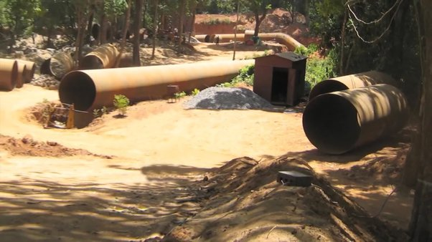
(image source : Netravathi River Diversion Project youtube video by Abhaya Simha) Pipeline laid for Yettinahole project
The idea is to build dams (weirs) on the eight streams, which flow into the Gundia river on the west side of the Western Ghats. Water from these dams will be pumped using electricity via tunnels drilled through the hills of the Western Ghats to three “delivery chambers”, and then to the final delivery chamber, which needs to be at an altitude of at least 1,300 m above sea level. From this chamber, the water will rush down a “gravity canal” for 250 km before reaching a 68-metre-deep reservoir to be built in Devaranyadurga near Tumkur town.
Verrapa Moily
We heard that politicians will be the most evil being; they can do anything for their political benefit. We saw it for real, when Verrapa Moily a son of Mangalore sold life line of his mother land for his political benefit.
The dominant issue in the Chikkaballapur constituency is water scarcity. One of the solutions proposed to tackle this emotive issue has been the implementation of the Yettinahole project involving the Netravathi river diversion.
During election season, dishing out pipe dreams, grand visions and promises that are built on pure hype. Veerappa Moily, the sitting MP of Chikkaballapur, recently pronounced Yettinahole project.
This goes for other politicians also.
Former CM and BJP leader Sadananda Gowda also supports the project. “Both the BJP and the Congress are trying to gain political mileage by supporting the Yettinahole project,”
On other hand many notable people from Mangalore joined hands to stop this unscientific project, one among them is professor S G Mayya
S G Mayya
According to S G Mayya, professor for water resource engineering, NITK Surthkal, “The project will be carried out in two phases.
In Phase I: Five weirs (low dams) will be constructed to streams, known as Yettinahole weir 1, Yettinahole tributary 1 weir 2, Yettinahole tributary 2, weir 3, Kadumanehole 1 weir 4, Kadumanehole 2 weir 5, with total catchment area of 87 sq km. From these 5 weirs, 12 tmc water will be collected.
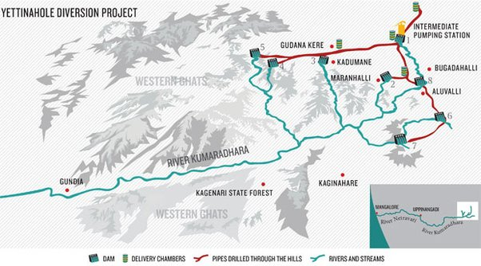
(image source: google images) Yettinahole river diversion project map
In Phase II: Three weirs constructed to streams known as Kerihole weir 6, Hongada Halla weir 7, Yetinahole d/s weir 8. Here catchment area will be 90 square km. A total of 12 tmc water will be collected from these weirs."
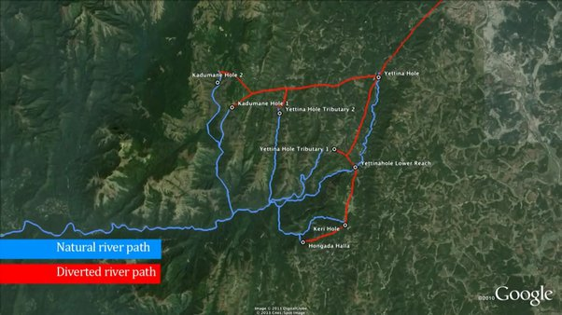
(image source: google earth) Yettinahole dams and project plan
He also asserts, “In Phase I, weir 1 is considered as the main weir from which water is lifted outside the basin. From weir 2, water will be lifted to a height of 172m to deliver chamber 1. In weirs 3, 4 and 5 water will be lifted to heights of 155m, 55m, and 105m respectively to deliver chamber 2. It is also said that water from delivery chambers 1 and 2 will be diverted to weir 1, through a natural stream.
Water collected in weir 1 is lifted to Doddanagar delivery chamber near Sakleshpur, and from Doddanagar to Haravanahalli chamber through a height of 45 and a rising main of length 7.88km. In Phase II water from Kerihole, Hongadahalla and Yettinahole d/s weirs will be lifted to delivery chamber 3 which will be at Doddanagara.”
On May 19, 2013, EI Technologies Pvt Ltd, Mumbai, submitted a feasibility report to Karnataka Niravari Nigama Limited.
“Fact is, the water lifted from the streams near the Western Ghats fills 198 tanks in Chikkaballapur and 139 tanks in Kolar. Apart from this, water is also made to feed various tanks of selected towns in Hassan district, Chikmagalur, Chitradurga, Tumkur, Madhugiri, Pavagada and Koratagere, Chamarajasagar reservoir, and Devanahalli industrial area, states the report. It is learnt from the report the project aims to not only solve the scarcity of drinking water, but even to rejuvenate rivers like Arkavathi, Palar, Jayamangali, Kushvathi, Uttara Pinakini, Dakshina Pinakini, Chitravathi, and Papanashini.”
K. Siddaramaiah
Year 2013 Siddaramaiah became chief minister of Karnataka state. He doesn’t have good relationship towards Costal districts which is Tulu speaking area. He belong to Kuruba community, also a leader of the Kuruba Gowda community, even Kanakadasa as saint belong to same community, Kanakadasa has a history in Udupi. In an interview to a magazine, chief minister Siddaramaiah indicated that he will take steps to get Udupi Krishna Mutt temple back under government control. However, later he declined his statement.
Despite widespread protests on March 3, 2014, by the locals and Dakshina Kannada industry bodies, Karnataka Chief Minister K. Siddaramaiah laid the foundation stone of the controversial Yettinahole project
However, it is learnt that the government, without preparing the DPR (detailed project report) has reserved funds for the project in the recent budget. It has also announced initiation of the tender process. In budget, Rs 200 Crores have been allocated for making DPR and initial works while Rs 2670 Crores have been sanctioned and Rs 850 Crores allocated for lift works up-to Harvanahalli in Sakaleshpura
March 11,2014 the man who behind Netravati river diversion project died, but at the same time he gave birth to his project.
As Paramasivaiya stated in his report, ‘Netravati river should be diverted to ‘Bayalu Seeme’ — the arid part of Karnataka, where more than 2 crore people live’ .
I would ask what about people of ‘Coastal districts’, a river which they dependent on, if it is diverted then this part also be arid, then who will be able to divert Netravati river back to Mangalore?
Course of Netravathi River
Netravathi River originates in the Western Ghats in Bangrabalike forest Valley in Yellaner Ghats of Kudremukha range in Karnataka. The Netravathi amalgamates with the Kumaradhara River near Uppinangadi village. Kumaradhara River also originates in Western Ghats in the Subramanya range. When it flows from Uppinangadi, it arrives in the city of Mangalore. After merging with Kumaradhara River, the Netravati then joins the Arabian sea. Along its course, the Netravati also flows through popular piligrim place called Dharmastala.
Estimation
According to government estimates, this reservoir will have a storage capacity of 11 TMC and submerge 1,200 hectares, including two villages and 600 hectares of forestland. Water from the reservoir will be pumped to Chikballapur and Kolar districts through two canals, 80 km and 55 km long, respectively. The scheme entails supplying water to 198 tanks in Chikballapur district and 139 tanks in Kolar district, says a study by the South Asia Network on Dams, Rivers and People, an NGO working on water-related issues.
Above estimate looks like this is not to fulfill drinking water, but to fulfill industrial needs!

(image source : google image) Above image shows pipeline used for Mangalore drinking water facility, which comes from BC road dam

(image source: daijjiworld) Monstrous pipe for Yettinahole project

(image source: daijjiworld) Yettinahole project site
Ecological Affect
According to the project report, 107 hectares of forests in the Western Ghats will have to be burned down to make way for the canals. The delivery chambers and pumping stations will also need to be built in forested areas. The ecological implications are staggering.
“Forest department has provided an alternative land, to get its clearance. At the same time they don’t have forest land for broadening ghat road stretch”
The Sakleshpura stretch of the Western Ghats was identified as an ‘Ecologically Sensitive Zone 1’ (a region of the highest sensitivity) by the Moeff-appointed Western Ghats Ecology Expert Panel headed by ecologist Madhav Gadgil. According to a study by the Indian Institute of Science, Bangalore, these forests are home to 119 tree species, 63 shrubs and climbers, 57 herbs and 44 species of butterflies, four dragon and damsel flies, 23 species of amphibians (including the threatened Gundia Indian Frog), 32 reptiles and 91 birds, besides the lion-tailed macaque, Slender Loris, Indian Gaur, elephants and even a handful of tigers.
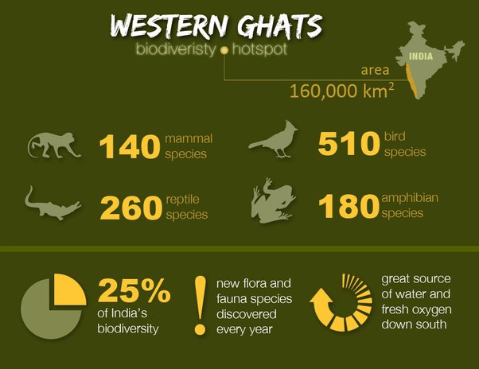
(image source: google image) Western Ghat info graphic
According to the analysis and estimation, the river is a living thing and its movement to another direction will impact the environment as it is against the nature’s laws. More specifically, the marine life of the river may be endangered, due to the reduction in the amount of freshwater outflow and the resultant decline of nutrients flowing into the sea. Deliberate changes in the course of the river may also adversely affect the contiguity of rainforest in Western Ghats. Fortunately, some opposition was raised against hydro electric projects on Netravati River, but Yettinahole project could not be stopped from being executed. River water is important for balancing the life sustaining elements in the sea.”
What if unscientific project implemented
Now
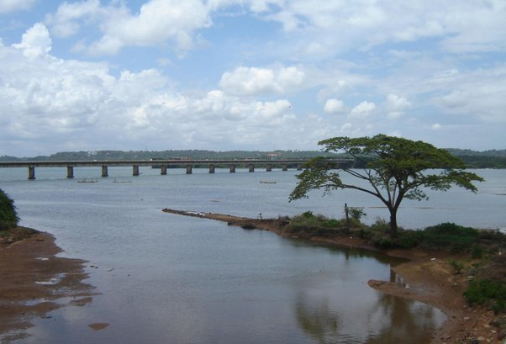
Later
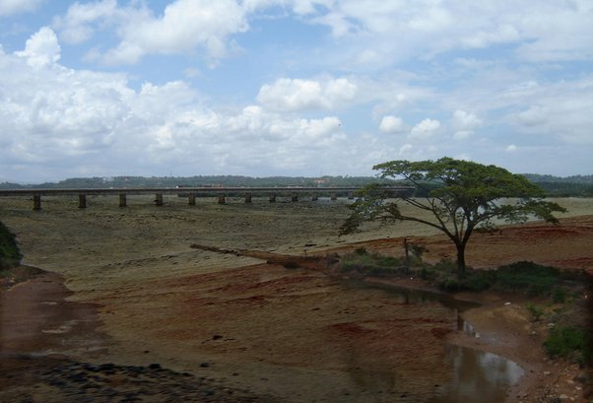
Now
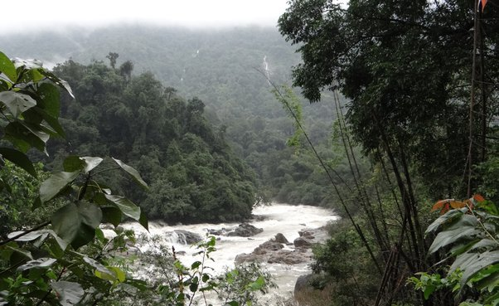
Later
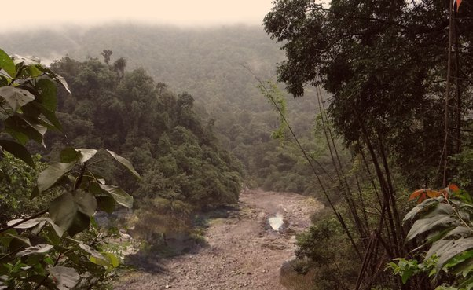
Share water for good cause, we Tulunaad people are with Bayalu-seeme people. Will join hands to solve water scarcity, this project will not provide solution for your water problems but this project is to fulfill greedy political benefits, this project will create problems, not only for us but for you also. Lets fight together against political greed.
Lets save our mother nature!
***Solmelu***

